**Checkout Service**:

This service enables system to send checkout information

This service will collect to checkout information like Username, TotalPrice, Address, Payment information and insert the information in the database.

**Architecture and Principles**

* Implementing **DDD, CQRS, and Clean Architecture** with using Best Practices
* Developing **CQRS with using MediatR, FluentValidation and AutoMapper packages**
* **SqlServer database** connection and containerization
* Using **Entity Framework Core ORM** and auto migrate to SqlServer when application startup
* REST API principles, CRUD operations

**Checkout REST Apis**

|  |  |  |
| --- | --- | --- |
| **Method** | **Request URI** | **Use Case** |
| GET | api/Order | Get Checkout information with username |
| POST | api/Order | Post checkout information and store it in database |

**High Level Design**

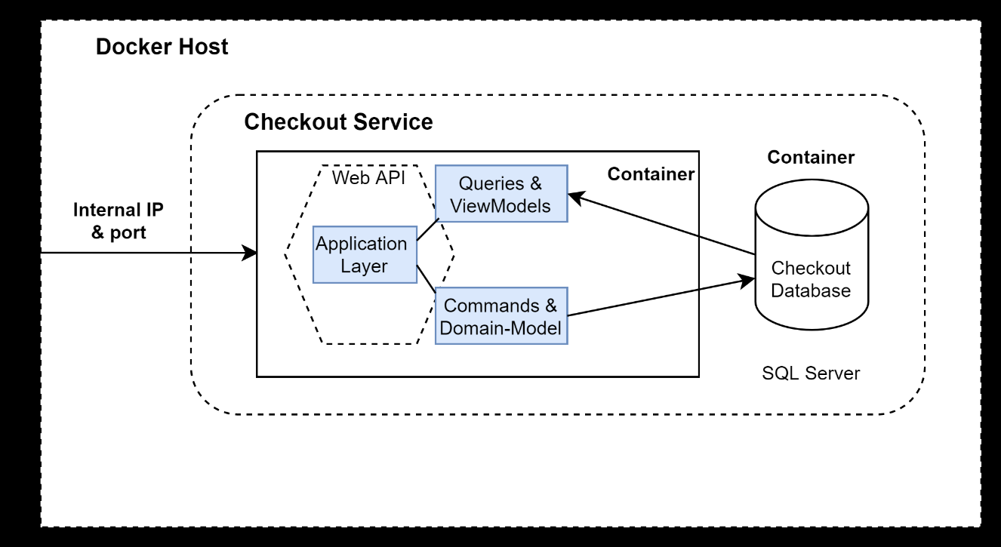

**Technologies Used**:

C#

Asp.net core 6.0

Docker Desktop

Kubernetes

**Code Structure**

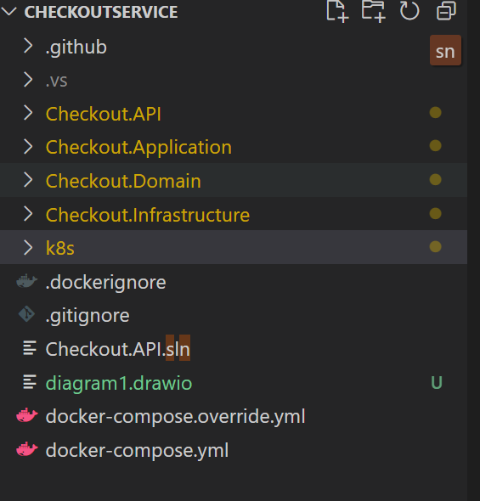

Run it locally using docker (Using Docker Desktop)

From command prompt run

docker-compose –f docker-compose.yml –f docker-compose-override.yml up –d

Run it locally using Kubernetes (Using Docker Desktop)

From command prompt run

Kubectl apply –f ./k8s

CI/CD

We have used GitHub action to build docker image and push it to docker hub when we will commit any changes to Main branch

**Feature Scope**

We can use github actions to deploy application to any cloud provide like Azure AKS, google gke, etc..